TEMPORAL EFFECTIVENESS OF BIODIVERSITY SURROGATES IN CORAL REEFS IN THE BRITISH VIRGIN ISLANDS

BY

NICOLE B. KEEFNER

A THESIS SUBMITTED IN PARTIAL FULFILLMENT OF THE

REQUIREMENTS FOR THE DEGREE OF

MASTER OF SCIENCE

IN

BIOLOGICAL AND ENVIRONMENTAL SCIENCES

UNIVERSITY OF RHODE ISLAND

2019

MASTER OF SCIENCE THESIS

OF

NICOLE B. KEEFNER

APPROVED:

THESIS COMMITTEE:

MAJOR PROFESSOR: GRAHAM FORRESTER

CO-MAJOR PROFESSOR: BRIAN GERBER

GAVINO PUGGIONI

CARLOS PRADA

DEAN OF THE GRADUATE SCHOOL: NASSER ZAWIA

UNIVERSITY OF RHODE ISLAND

2019

**ABSTRACT**

Biodiversity is declining around the world, necessitating rapid identification of species distribution contractions and population declines to identify conservation priorities. Surrogates are increasingly being used to meet this challenge. A good surrogate is expected to be easier to monitor than the target component of biodiversity and meets the assumption that the target-surrogate relationship is constant over space and time. Our objective was to evaluate the spatio-temporal stability of surrogates in coral reef systems. We used data from an ongoing 27-year monitoring program in the British Virgin Islands that has quantified the abundance and species richness of fish, coral, and sponge species at 8 sites. Of these taxa, corals are the most widely monitored and measures of total coral cover and the 3-dimensional structure provided by corals (rugosity) are often assumed to be good surrogates for diversity of reef-associated taxa. We thus hypothesize that coral cover and rugosity will be good surrogates for fish, coral, and sponge species richness. Because species-level identification is challenging in the field, we also investigated how the monitoring of recognizable taxonomic units (RTU’s) compares to species-level studies. We sought correlated relationships between the proposed surrogates and fish, coral, and sponge species richness. Our results provide insight on the use of surrogates in a coral reef ecosystem and on the inclusion of RTU’s in biodiversity studies. The identification of surrogates that maintain stable relationships with target components of biodiversity over time can inform decisions regarding existing data from monitoring studies and the allocation of limited resources for collection of future data.

**ACKNOWLEDGEMENTS**

I would like to thank Dr. Graham Forrester, my major professor, for his continuous support and guidance throughout my time at the University of Rhode Island. I would also like to thank my co-major professor, Dr. Brian Gerber, and the committee members, Dr. Gavino Puggioni and Dr. Carlos Prada, for contributing so thoughtfully to the organization and analysis of this work. Thanks to Dr. Rachel Schwartz for chairing the committee and teaching me about version control for the programs I created for the analysis. For feedback and encouragement on presentations, early drafts, and discussions about my work, I am grateful to Elliot Lungu, Innocent Gumulira, Vida Osei, Erin Wampole, Dylan Ferreira, Juliana Masseloux, Sarah Holbrook, Katie Nickles, and Celeste Venolia. I extend my gratitude to my partner Anthony Peterson for trouble-shooting code with me over the phone. A special thanks to Dr. Lianna Jarecki and Linda Forrester who collected data used in this study. Thanks to Guana Island Staff for logistical support. This project would not have been possible without support from the University of Rhode Island through graduate teaching assistantships.

**DEDICATION**

This thesis is dedicated to my loving mother, Teresa M. Keefner, my support in all things that led me to complete this work and the woman who taught me to persist through even the most inconceivable challenges.

**PREFACE**

The following thesis has been submitted in manuscript format following the formatting guidelines of the *Journal for Nature Conservation*.

**TABLE OF CONTENTS**

**LIST OF TABLES**

**LIST OF FIGURES**

**CHAPTER 1**

Temporal effectiveness of biodiversity surrogates in coral reefs in the British Virgin Islands

**Authors**

Nicole B. Keefner[1]; Graham E. Forrester[2]

Manuscript in preparation for *Journal for Nature Conservation*

# Abstract

Biodiversity is declining around the world, necessitating rapid identification of species distribution contractions and population declines to identify conservation priorities. Surrogates are increasingly being used to meet this challenge. A good surrogate is expected to be easier to monitor than the target component of biodiversity and meets the assumption that the target-surrogate relationship is constant over space and time. Our objective was to evaluate the spatio-temporal stability of surrogates in coral reef systems. We used data from an ongoing 27-year monitoring program in the British Virgin Islands that has quantified the abundance and species richness of fish, coral, and sponge species at 8 sites. Of these taxa, corals are the most widely monitored and measures of total coral cover and the 3-dimensional structure provided by corals (rugosity) are often assumed to be good surrogates for diversity of reef-associated taxa. We thus hypothesize that coral cover and rugosity will be good surrogates for fish, coral, and sponge species richness. Because species-level identification is challenging in the field, we also investigated how the monitoring of recognizable taxonomic units (RTU’s) compares to species-level studies. We sought correlated relationships between the proposed surrogates and fish, coral, and sponge species richness. Our results provide insight on the use of surrogates in a coral reef ecosystem and on the inclusion of RTU’s in biodiversity studies. The identification of surrogates that maintain stable relationships with target components of biodiversity over time can inform decisions regarding existing data from monitoring studies and the allocation of limited resources for collection of future data.

# Introduction

Biodiversity declines associated with increasing levels of anthropogenic stress are of great concern because they reflect loss of species, disruption of community dynamics and diminished ecosystem function (Dobson et al., 2006; Duffy, 2009; Ehrlich & Wilson, 1991; Naeem, Thompson, Lawler, Lawton, & Woodfin, 1994; Staudinger et al., 2013; Stork, 2010). To monitor these declines, different aspects of biodiversity (landscape, ecosystem, taxonomic, and genetic) may be compared across similar systems over time and space (Duelli & Obrist, 2003; Noss, 1990). Taxonomic diversity, particularly species richness (a count of species in a defined area), is the most commonly studied component of biodiversity in ecological and conservation-related field research because it offers a simple intuitive metric of biodiversity that can be readily compared across similar environments (Blake & Loiselle, 2000; Rahbek & Graves, 2001).

Coral reefs support high biodiversity and are globally threatened by environmental and anthropogenic stressors, including ocean acidification, persistent high temperatures, and overfishing (Comeau, Lantz, Edmunds, & Carpenter, 2016; Hughes, 1994; Hughes et al., 2017). Reef fishes and hard corals (Scleractinia) are dominant coral reef organisms that establish and maintain biodiversity by filling multiple functional roles in coral reef systems (Bellwood, Hughes, Folke, & Nyström, 2004). They are also economically valuable because they attract tourists and fish serve as a valuable food source (Gill, Schuhmann, & Oxenford, 2015; Jennings & Polunin, 1996). Concerns regarding the declines of corals and fish given their ecological and economic values motivate many monitoring programs to estimate richness of these groups and understand causes of decline (Mouillot et al., 2014; Nystrom, 2006).

Unfortunately, a complete inventory of species present in an area is unattainable in many ecosystems, particularly in high diversity systems like coral reefs. Even for taxonomic groups that can be completely inventoried in principle, monitoring strategies that could detect all species in a given habitat are often prohibitively expensive and time-consuming (Kati et al., 2004). Monitoring species richness requires substantial taxonomic expertise (Hirst, 2008; Sebek et al., 2012). Moreover, some species that can be recognized in the lab using morphological features or genetic markers cannot be distinguished in situ during field surveys. When species cannot be reliably distinguished in the field, studies sometimes use recognizable taxonomic units (RTU’s) or morphospecies that are defined by readily identifiable characteristics in the field (Derraik et al., 2002). Alternatively, landscape features do not require species identification and can improve simplicity and affordability of studies. As a result, biologists have attempted to identify landscape features that may be used as simpler predictors of reef biodiversity. The most commonly measured landscape features of coral reefs are hard coral cover and structural complexity (rugosity). In fact, the temporal decline of these reef features is widely documented because they are so frequently measured (Alvarez-Filip, Dulvy, Gill, Côté, & Watkinson, 2009; Gardner, Côté, Gill, Grant, & Watkinson, 2003). Sponges play a dominant role in the benthic composition of the reef and contribute to the reef’s three-dimensional structure (Bell, 2008) and yet few studies have investigated sponge dynamics (Berman et al., 2013; Wulff, 2006). Not much is known about the relationship between coral cover or rugosity and sponge richness or about sponge cover as a way of predicting coral and fish richness.

These landscape feature predictors of coral reef biodiversity can be thought of as potential surrogates, simple indicators that provide an estimate of a target component of biodiversity, often referred to more simply as a target (Noss, 1990). An effective surrogate has two essential features: first, it takes less time, money, and experience to measure than the target and second it maintains a consistently strong correlation with the target over space and time (Colwell & Coddington, 1994; Magierowski & Johnson, 2006; Moreno, Rojas, Pineda, & Escobar, 2007).Evaluating the ability for these predictors to be used as surrogates might inform monitoring efforts that have limited resources and lead to a greater understanding of how the relationships between these predictors and biodiversity change over time and space. Most surrogate studies to date have been concerned with the effectiveness of surrogates across spatial scales (Anderson, Diebel, Blom, & Landers, 2005; Darling et al., 2017; Eglington, Noble, & Fuller, 2012; Smale, 2010). The prevalence of studies considering surrogates across spatial scales may be due to the widespread use of surrogates to identify priority conservation areas; this task requires an understanding of how the size and dispersion of the areas being conserved will affect the dynamics between the surrogate and target (Margules, Pressey, & Williams, 2002; Padoa-Schioppa, Baietto, Massa, & Bottoni, 2006; Ward, Vanderklift, Nicholls, & Kenchington, 1999). However, few studies have explicitly investigated surrogate effectiveness across temporal scales, and those that have are typically quite short (e.g., 13 months and 1 year; Magierowski & Johnson, 2006; Rubal, Veiga, Vieira, & Sousa-Pinto, 2011). Despite not always being their primary focus, authors recognize that an effective surrogate must maintain a stable relationship with the target over time, in other words any environmental changes that influence the target must have a qualitatively similar influence on the surrogate (Bevilacqua et al., 2018; Lewandowski et al., 2010; Mellin et al., 2011). The need for more studies that investigate the effectiveness of surrogates over time is evident.

Here, we evaluate the ability of percent hard coral cover, percent sponge cover, and rugosity to predict species richness of corals, fishes, sponges, and combined richness (as the sum of richness across these three groups) using 27 years of monitoring data from eight sites around Guana Island in the British Virgin Islands(Forrester et al., 2015). Our first objective was to determine, for each of the four targets separately, which of these three candidate surrogates is the best predictor. Our second objective was to determine if the relationships between the best candidate surrogate for each target and the corresponding target remain consistent over space and time. We expected coral cover to be the best surrogate for coral species richness because presumably, the more area covered by corals, the greater variety of microhabitats they inhabit, and the greater number of species that would be present and, similarly, that sponge cover would be the best surrogate for sponge species richness. We also expected rugosity to be the best surrogate for fish species richness as well as combined species richness because a greater number of macrobenthic species should increase the number of coral and sponge morphological types and increase rugosity, even though these sites may be dominated by a few species (Alvarez-Filip, Dulvy, Côté, Watkinson, & Gill, 2011). In addition, greater rugosity should provide a wider variety of structures that may be utilized by a greater diversity of fish species (Darling et al., 2017; Graham et al., 2006; Gratwicke & Speight, 2005; Newman et al., 2015) and different fish species utilize the structure of the reef when coral is alive versus when it’s dead (Wilson, Graham, Pratchett, Jones, & Polunin, 2006).

**Material and Methods**

## Field study design

We used data collected as part of an ongoing monitoring program at eight sites around Guana Island in the British Virgin Islands (Fig. 1)(Forrester et al., 2015). All sites were similar in covering 0.6-1.0 hectares of fringing coral reef adjacent to the island at a depth of 9-10 m. Sites varied in exposure to prevailing weather; sites on the windward north side of the island are more exposed than those on the southern leeward side (Fig. 1). Corals, fishes, and rugosity were sampled annually between June and August from 1992-2018, but sponges were not sampled in all years (no counts in 1992, 1996-1999, 2004, 1993 at Crab Cove, 2014 at Pelican Ghut, and 2017 at Bigelow Beach and Pelican Ghut). All surveys were performed using 30-m transects, placed at haphazardly selected locations within each site. The number of transects sampled per site varied among years (n = 3-22) but, for this study, three transects per site per year were selected at random for use in the analysis.

## Survey methods

Corals, sponges, fishes, and rugosity were sampled using well-established visual survey methods.

Fishes were counted within a belt transect 30 m long x 1.5 m wide, and a T-shaped bar was used to determine the transect width as the diver swam along the transect line. Fish counts were restricted to species that are amenable to visual survey; that is, day-active species that are relatively site-attached and reliably visible to divers(Willis, 2001). Nocturnal species, highly mobile groups such as mackerels (Scombridae) and jacks (Carangidae) that are transient visitors to the sites, and small cryptic groups like gobies (Gobiidae) and blennies (Blennioidei) that often hide in crevices were not surveyed. Newly recruited juvenile fishes (< 1 month on the reef) were also excluded because their abundance is affected by lunar cycles, which complicates the detection of long-term trends(Robertson, 1992). Because fish were the only mobile organisms surveyed, the fish survey was conducted first for each transect in order to reduce the bias caused by divers disturbing the fish(Emslie, Cheal, MacNeil, Miller, & Sweatman, 2018).

Corals and other benthic taxa were surveyed using the linear point-intercept method, wherein a diver swam along the tape and identified the taxon under the tape at 0.25 m intervals (n = 120 points per transect)(Canfield, 1941). Corals encountered were identified to species, where possible, but other taxa (including sponges) were classified into broader groupings. The point-intercept data was thus used to estimate coral species richness as well as the total abundance (% cover) of hard corals and sponges(Almada-Villela, Sale, Gold-Bouchot, & Kjerfve, 2003).

To estimate sponge species richness, sponges were surveyed using a line intercept method in which any sponge that intercepted the transect was recorded and identified to species, where possible.

Rugosity was measured as a proxy for three-dimensional structural complexity using the consecutive height difference method(McCormick, 1994), where a diver records the difference between the height of the transect tape and the substrate at 1 m intervals along the first 10 m of each transect. Rugosity (in cm) is calculated as the square root of the sum of the squared differences between successive height measurements, and so a value of 0 is flat and vertical complexity increases as the rugosity value increases.

To minimize bias introduced by using multiple observers, fish counts and sponge counts were each made by a single expert observer(Bernard, Götz, Kerwath, & Wilke, 2013; Thompson & Mapstone, 1997), though both observers compared their counts and species identifications to those of another expert one year (data not shown). Coral data were collected by three observers, but new observers’ species identifications and counts were calibrated with those of another observer during a training period of at least 15 dives before their data were incorporated into the study.

Identifying taxa to species is not always possible or practical in field surveys, and fish, corals and sponges were identified to the most specific taxonomic group practical (Appendices 1-2). All fish were identified to species, while corals and sponges were sometimes identified as multi-species recognizable taxonomic units(Ward & Stanley, 2004), or RTU’s, for the following reasons: (1) taxonomists reassigned taxa thought to be different species to the same species after the study began, (2) taxonomists divided a single species into multiple species after the study began, and (3) several species are visually indistinguishable in the field. In all cases, the lowest resolution RTU was used, and for simplicity RTU’s are referred to as “species” hereafter. We suggest that the use of RTU’s, although it affects estimates of absolute species richness, should not alter the outcome of the analysis.

## Statistical Analysis

## We used sites as replicates because they represent spatial units of relevance from both ecological and management perspectives. For surrogates (coral cover, sponge cover, and rugosity), replicates were thus means for the 3 randomly-selected transects per site per year. To estimate species richness, we pooled the same 3 randomly-selected transects for each year and site and calculated the total number of fish, coral and sponge species observed. Species richness is hereafter called combined richness, and was only calculated for sites and years for which richness of all three taxonomic groups was available.

Based on first principles, we used negative binomial regression using the ‘MASS’ package to model richness because it is a count variable(Venables & Ripley, 2002). All models, therefore, have an additional parameter, theta, that accounts for overdispersion. There were no patterns in the Pearson residuals or deviance residuals for any of the models included in the analysis.

To determine which of the candidate surrogates is best at predicting each of the targets, we used simple models with only the candidate surrogates as predictors. We then compared these simple, surrogate-only models using Akaike Information Criterion corrected for small sample sizes (AICc)(Mazerolle, 2019). AICc results provide a measure of parsimony in that they can be used to identify models with the fewest parameters and the greatest explanatory ability relative to other models in the model set. Top models were those with delta AICc ≤ 2 and AICc weights > 50%. Nagelkerke’s pseudo-r-squared values were also used for model interpretation by providing a measure of goodness-of-fit in that they can be used to compare how much each surrogate improves the ability to predict a given target. Pseudo-r-squared was used instead of traditional r-squared because the negative binomial distribution was used. Nagelkerke’s pseudo-r-squared (*R*N2) was used instead of similar values because it is more interpretable (ranges from 0-1) and is used to evaluate the improvement from a null to a fitted model. Only the top candidate surrogate identified for each target from this comparison was used for subsequent modeling.

To determine if relationships between top candidate surrogates and the targets remain consistent over space and time, we added additional terms to the surrogate-only models to account for temporal variation and variation across sites. Site is a categorical predictor of the 8 locations around Guana Island and year is a temporal trend across all sites within similar areas over the 27 years. For each of the targets (dependent variables), surrogate-only models were compared using AICc to models with additional terms for year, site, and year plus site to determine if there’s unexplained variation in the data over time, across sites, or over time and across sites that cannot be accounted for by the surrogate alone. For example, the model with the top candidate surrogate and year would mean that the candidate surrogate maintained a correlation with the target over space, but that there was still some variation over time that could not be accounted for by the surrogate alone. This might make it good at predicting the target across nearby sites that were monitored in the same time frame. Similarly, the model with the top candidate surrogate, year, and site would mean the candidate surrogate maintained a correlation with the target over time, but that there was still some variation over space and time that could not be accounted for by the surrogate alone. Assuming the surrogate coefficient is significant, this means the surrogate might correlate with the target, but that site and time must be accounted for, thus defeating the purpose of using the surrogate in a predictive capacity over space and time, but can still be used to estimate the target. These additive models were also compared to models with interactive terms for the surrogate with year and the surrogate with site. These interactive models would suggest that the relationship between the target and the top candidate surrogate changes over time or across sites. Again, top models were those with delta AICc ≤ 2 and AICc weights > 50%. Nagelkerke’s pseudo-r-squared values (*R*N2) were also used for additional model support.

We did not consider more complex models for this study because, if more complex models were supported, the relationship between the candidate surrogate and the target would not be valuable for monitoring purposes. In other words, the ecological interpretation of these more complex models would be complicated enough that there would be no clear relationship between the candidate surrogate and the target, suggesting that the candidate surrogates do not provide the benefits of a good surrogate.

To supplement the primary analysis, we conducted a full exploratory analysis for each of the four targets that includes the models described above for all three candidate surrogates as well as models without candidate surrogates to evaluate how much the candidate surrogates were contributing to the models described above (Appendices 3-6). All data management and analysis was performed in the R programming language(R Core Team, 2019).

# Results

## Summary statistics

## We recorded 205 species across all 27 years for all 8 sites around Guana Island. There were 117 fish species, 30 coral species, and 58 sponge species. For each site and year combination, coral richness ranges from 4 to 22 (mean = 13), sponge richness ranges from 8 to 36 (mean = 22), fish richness ranges from 9 to 37 (mean = 24), and combined richness ranges from 39 to 75 (mean = 59). Percent coral cover ranged from 2.68 to 61.75 (mean = 21.36), percent sponge cover ranged from 0.28 to 27.77 (mean = 7.96), and rugosity ranged from 17 to 78 (mean = 45.37).

## Objective 1: Identify top candidate surrogates

Coral cover and rugosity were both positively correlated with coral richness, but the correlation was stronger for coral cover and so it was clearly the top candidate surrogate for coral richness (Tab. 1; Fig. 2). Sponge cover showed a weak positive association with sponge richness, and there was a weak negative association between coral cover and sponge richness. Coral cover, however, was a slightly better predictor of sponge richness and so was the top candidate surrogate (Tab. 2; Fig. 2). Fish species richness was positively correlated with both coral cover and rugosity, but, for this target group, rugosity was clearly the best predictor of fish richness and was the top candidate surrogate for fish richness (Tab. 3; Fig. 2) and combined richness (Tab. 4; Fig. 2).

## Objective 2: Top candidate surrogates over time and space

Coral Richness:

Variation in coral richness can partially be explained by coral cover as a candidate surrogate. However, the model with coral cover and year was the most competitive (*R*N2 = 0.69; Tab. 5), which means there are changes in coral richness over time that are not explained by the candidate surrogate alone. This suggests that there are temporal events that affect coral richness and coral cover differently. Evidence to support this can be seen by looking at each of these variables over time; average coral richness increases slightly over the study period, whereas coral cover steadily declines throughout the same period. There is also support that the nature of the relationship between coral cover and coral richness (i.e. the slope of the relationship) changes over time (Tab. 5), suggesting a 1 percent increase in coral cover for a given year will have a different effect on coral richness in any other year. In other words, coral species richness increases over time for a given amount of coral cover. For example, a reef with 20 percent coral cover in 1992 is predicted to have about 9 coral species, whereas in 2018 it is predicted to have about 17 coral species (Fig. 3).

Sponge Richness:

Sponge richness was not well-predicted by any of our candidate surrogates; low pseudo-r-squared values suggest that none of the candidate surrogates seems to be strongly related to sponge richness (Fig. 2). Fish richness and coral richness are positively correlated, whereas sponge richness is negatively correlated to both of these, suggesting sponge richness varies in space and time independent of changes in fish and coral richness. Similarly, rugosity and coral cover are positively correlated, whereas sponge cover is negatively correlated to both of these, suggesting sponge cover also varies in space and time independent of changes in rugosity and coral cover. Coral cover was the best predictor of sponge richness, but there was still considerable unexplained variation over time and across sites (*R*N2 = 0.71; Tab. 6). These unexplained spatial differences among the 8 sites have a greater influence on sponge richness than they do on coral cover (Fig. 4). For a given site, predicted sponge richness varies by about 2-3 species across the observed gradient of coral cover. Whereas, for a given amount of coral cover, predicted sponge richness differs by up to 8-9 species. With regards to temporal variation, sponge species richness slightly increases over the monitoring period for a given amount of coral cover. A site is likely to have about 3 more sponge species at the end of the monitoring period than at the beginning (Fig. 5).

Fish Richness:

Fish richness can partially be explained by rugosity as a candidate surrogate. However, the top model has terms for both rugosity and site (*R*N2 = 0.82; Tab. 7), suggesting there are variations in fish richness across sites that are not explained by rugosity alone. These spatial variations among the 8 sites are likely due to the fact that most of these sites remain quite distinct in rugosity over time. For example, Pelican Ghut has the lowest rugosity throughout the monitoring period, and correspondingly low fish richness (Fig. 6). Monkey Point has the next lowest rugosity and the next lowest fish richness, and so on. White Bay and Crab Cove show greater variation in rugosity over time than other sites, which might explain why the site-specific regression lines have shallower slopes than a line fit through all of the data (Fig. 2). In summary, the relationship between rugosity and fish richness is consistent over time, and, because rugosity varies significantly across sites and not much within a site, fish richness remains relatively stable over site and time and can be estimated by rugosity. Given this, sites with similar values for rugosity should have similar values of fish richness and this is evidence that rugosity can serve as a surrogate for fish richness.

Combined Richness:

Combined richness can partially be explained by rugosity as a candidate surrogate. However, the top model has terms for rugosity, year, and site (*R*N2 = 0.65; Tab. 8), suggesting there are variations in combined richness across sites and years that are not explained by rugosity alone. Similar to the relationship between rugosity and fish richness, these spatial variations among the 8 sites are likely due to distinct rugosity values for each site over time. The sites are organized differently on the y-axis for combined richness than they are for fish richness likely driven by variations in sponge richness across sites that follow a different pattern over time (Fig. 7). Similar to the association with fish richness above, the site-specific regression lines have shallower slopes than a line fit through all of the data due to the variation in rugosity over time at White Bay and Crab Cove (Fig. 2). With regards to temporal variation, combined species richness gradually increases over the monitoring period for a given amount of rugosity; a site is likely to have about 15 more species in 2018 than it had in 1993 (Fig. 8).

In summary, rugosity varies significantly across sites and not much within a site and combined richness increases gradually over time, suggesting combined richness can be predicted by rugosity at a given site and that this combined richness is expected to increase over time for a given level of rugosity. Rugosity may serve as a surrogate for combined richness across sites, but it fails to explain the increase in combined richness over time. There may be some other ecological explanation for this, such as the increase in sponge species over time having more of an impact on combined richness than the more subtle changes in fish and coral richness over the same time period.

## Exploratory analysis

See appendices 3-6 for AICc tables from the full exploratory analyses for each of the 4 targets with all models for all three candidate surrogates.

# Discussion

Taxonomic diversity on coral reefs has declined due to anthropogenic stressors. These declines have motivated monitoring programs to estimate species richness for major taxonomic groups: fish and corals. Due to logistical challenges of species identification, there have been efforts attempting to estimate species richness on reefs using landscape features as surrogates. Many of these efforts are limiting in spatial or temporal scope. Here we identify reef features that might be able to serve as reliable surrogates for coral, fish, and combined richness over time and across 8 study sites. This study is also one of the first that includes sponge richness and sponge cover as a predictor of coral and fish richness. We show here that including sponges in monitoring studies may provide a broader understanding of how biodiversity is changing on reefs.

*Landscape reef features correlating with changes in coral, fish, and combined richness*

Surrogates should be evaluated by their ability to predict targets over time and space. They can help reduce the amount of time and money required to monitor coral reefs, but the temporal and spatial limitations of their use should be explicitly addressed when planning large-scale or long-term studies.

Fish richness and combined richness were both correlated most closely with rugosity. In both of these cases, the relationship was driven by spatial differences in rugosity. Combined richness also increased over time. White Bay and Crab Cove have high variability in rugosity over time compared to other sites. This suggests that there might be some factor affecting rugosity at these two sites leading to subsequent fluctuations in fish richness and combined richness.

Coral richness correlated most closely with coral cover and varied over time. One explanation for the increase in coral species richness for a given amount of coral cover over time is that evenness might increase over time. In other words, the abundance of the most dominant species is reduced over time.

*Value of sponge monitoring*

# The traditional measures of coral cover and rugosity might be good predictors of coral richness and fish richness respectively, but caution should be used when making extrapolations to total reef diversity as richness of some groups, here we looked at sponge richness, is not strongly correlated to these variables. Similarly, sponge cover does not follow the same patterns as coral cover or rugosity over time or across sites. Because sponge richness and sponge cover both follow different patterns than other variables in this study, sponges can give us a fuller picture of reef biodiversity. Perhaps sponges are not the only taxonomic group of organisms on coral reefs that are difficult to predict with coral cover or rugosity and should be measured directly until a reliable surrogate can be identified. If not, studies that comment on reef biodiversity should be transparent about which taxonomic groups they include in their estimates.

In conclusion, we show here that the commonly measured surrogates, rugosity and percent coral cover, can be reliable predictors of fish richness and coral richness respectively. However, we suggest that future reef biodiversity studies incorporate sponge-related measures to get a broader interpretation of reef biodiversity as they reveal different patterns than other measures. Reef biodiversity studies that do not incorporate sponge-related measures should be explicit about the taxonomic groups included in the analyses and exercise caution when estimating total reef biodiversity.

**Acknowledgements**

Thanks to Dr. Brian Gerber, Dr. Gavino Puggioni and Dr. Carlos Prada for their assistance in the development and review of this study. We are grateful to Dr. Lianna Jarecki and Linda Forrester who collected much of the data on sponges and corals. We also thank the Guana Island staff for logistical support.

# Literature Cited

Almada-Villela, P. C., Sale, P. F., Gold-Bouchot, G., & Kjerfve, B. (2003). *Manual of methods for the MBRS synoptic monitoring program: Selected methods for monitoring physical and biological parameters for use in the Mesoamerican region*. Belize City: Mesoamerican Barrier Reef Systems project (MBRS).

Alvarez-Filip, L., Dulvy, N. K., Côté, I. M., Watkinson, A. R., & Gill, J. A. (2011). Coral identity underpins architectural complexity on Caribbean reefs. *Ecological Applications*, *21*(6), 2223–2231.

Alvarez-Filip, L., Dulvy, N. K., Gill, J. A., Côté, I. M., & Watkinson, A. R. (2009). Flattening of Caribbean coral reefs: Region-wide declines in architectural complexity. *Proceedings of the Royal Society B*, *276*, 3019–3025.

Anderson, M. J., Diebel, C. E., Blom, W. M., & Landers, T. J. (2005). Consistency and variation in kelp holdfast assemblages: Spatial patterns of biodiversity for the major phyla at different taxonomic resolutions. *Journal of Experimental Marine Biology and Ecology*, *320*, 35–56.

Bell, J. J. (2008). The functional roles of marine sponges. *Estuarine, Coastal and Shelf Science*, *79*, 341–353.

Bellwood, D. R., Hughes, T. P., Folke, C., & Nyström, M. (2004). Confronting the coral reef crisis. *Nature*, *429*, 827–833.

Berman, J., Burton, M., Gibbs, R., Lock, K., Newman, P., Jones, J., & Bell, J. (2013). Testing the suitability of a morphological monitoring approach for identifying temporal variability in a temperate sponge assemblage. *Journal for Nature Conservation*, *21*, 173–182.

Bernard, A. T. F., Götz, A., Kerwath, S. E., & Wilke, C. G. (2013). Observer bias and detection probability in underwater visual census of fish assemblages measured with independent double-observers. *Journal of Experimental Marine Biology and Ecology*, *443*, 75–84.

Blake, J. G., & Loiselle, B. A. (2000). Diversity of birds along an elevational gradient in the Cordillera Central, Costa Rica. *The Auk*, *117*(3), 663–686.

Canfield, R. H. (1941). Application of the line interception method in sampling range vegetation. *Journal of Forestry*, *39*, 388–394.

Colwell, R. K., & Coddington, J. A. (1994). Estimating terrestrial biodiversity through extrapolation. *Philosophical Transactions of the Royal Society B*, *345*, 101–118.

Comeau, S., Lantz, C. A., Edmunds, P. J., & Carpenter, R. C. (2016). Framework of barrier reefs threatened by ocean acidification. *Global Change Biology*, *22*, 1225–1234.

Darling, E. S., Graham, N. A. J., Januchowski-Hartley, F. A., Nash, K. L., Pratchett, M. S., & Wilson, S. K. (2017). Relationships between structural complexity, coral traits, and reef fish assemblages. *Coral Reefs*, *36*, 561–575.

Derraik, J. G. B., Closs, G. P., Dickinson, K. J. M., Sirvid, P., Barratt, B. I. P., & Patrick, B. H. (2002). Arthropod morphospecies versus taxonomic species: A case study with Araneae, Coleoptera, and Lepidoptera. *Conservation Biology*, *16*(4), 1015–1023.

Dobson, A., Lodge, D., Alder, J., Cumming, G. S., Keymer, J., McGlade, J., … Xenopoulos, M. A. (2006). Habitat loss, trophic collapse, and the decline of ecosystem services. *Ecology*, *87*(8), 1915–1924.

Duelli, P., & Obrist, M. K. (2003). Biodiversity indicators: The choice of values and measures. *Agriculture, Ecosystems and Environment*, *98*, 87–98.

Duffy, J. E. (2009). Why biodiversity is important to the functioning of real-world ecosystems. *Frontiers in Ecology and the Environment*, *7*(8), 437–444.

Eglington, S. M., Noble, D. G., & Fuller, R. J. (2012). A meta-analysis of spatial relationships in species richness across taxa: Birds as indicators of wider biodiversity in temperate regions. *Journal for Nature Conservation*, *20*, 301–309.

Ehrlich, P. R., & Wilson, E. O. (1991). Biodiversity studies: Science and policy. *Science*, *253*(5021), 758–762.

Emslie, M. J., Cheal, A. J., MacNeil, M. A., Miller, I. R., & Sweatman, H. P. A. (2018). Reef fish communities are spooked by scuba surveys and may take hours to recover. *PeerJ*.

Forrester, G., Baily, P., Conetta, D., Forrester, L., Kintzing, E., & Jarecki, L. (2015). Comparing monitoring data collected by volunteers and professionals shows that citizen scientists can detect long-term change on coral reefs. *Journal for Nature Conservation*, *24*, 1–9.

Gardner, T. A., Côté, I. M., Gill, J. A., Grant, A., & Watkinson, A. R. (2003). Long-term region-wide declines in Caribbean corals. *Science*, *301*, 958–960.

Gill, D. A., Schuhmann, P. W., & Oxenford, H. A. (2015). Recreational diver preferences for reef fish attributes: Economic implications of future change. *Ecological Economics*, *111*, 48–57.

Graham, N. A. J., Wilson, S. K., Jennings, S., Polunin, N. V. C., Bijoux, J. P., & Robinson, J. (2006). Dynamic fragility of oceanic coral reef ecosystems. *Proceedings of the National Academy of Sciences of the United States of America*, *103*(22), 8425–8429.

Gratwicke, B., & Speight, M. R. (2005). The relationship between fish species richness, abundance and habitat complexity in a range of shallow tropical marine habitats. *Journal of Fish Biology*, *66*, 650–667.

Hirst, A. J. (2008). Surrogate measures for assessing cryptic faunal biodiversity on macroalgal-dominated subtidal reefs. *Biological Conservation*, *141*, 211–220.

Hughes, T. P. (1994). Catastrophes, phase shifts, and large-scale degradation of a Caribbean coral reef. *Science*, *265*(5178), 1547–1551.

Hughes, T. P., Kerry, J. T., Álvarez-Noriega, M., Álvarez-Romero, J. G., Anderson, K. D., Baird, A. H., … Wilson, S. K. (2017). Global warming and recurrent mass bleaching of corals. *Nature*, *543*, 373–377.

Jennings, S., & Polunin, N. V. C. (1996). Impacts of fishing on tropical reef ecosystems. *Ambio*, *25*(1), 44–49.

Kati, V., Devillers, P., Dufrêne, M., Legakis, A., Vokou, D., & Lebrun, P. (2004). Testing the value of six taxonomic groups as biodiversity indicators at a local scale. *Conservation Biology*, *18*(3), 667–675.

Magierowski, R. H., & Johnson, C. R. (2006). Robustness of surrogates of biodiversity in marine benthic communities. *Ecological Applications*, *16*(6), 2264–2275.

Mazerolle, M. J. (2019). AICcmodavg: Model selection and multimodel inference based on (Q)AIC(c).

McCormick, M. I. (1994). Comparison of field methods for measuring surface topography and their associations with a tropical reef fish assemblage. *Marine Ecology Progress Series*, *112*, 87–96.

Moreno, C. E., Rojas, G. S., Pineda, E., & Escobar, F. (2007). Shortcuts for biodiversity evaluation: A review of terminology and recommendations for the use of target groups, bioindicators and surrogates. *International Journal of Environment and Health*, *1*(1), 71–86.

Naeem, S., Thompson, L. J., Lawler, S. P., Lawton, J. H., & Woodfin, R. M. (1994). Declining biodiversity can alter the performance of ecosystems. *Nature*, *368*(6473), 734–737.

Newman, S. P., Meesters, E. H., Dryden, C. S., Williams, S. M., Sanchez, C., Mumby, P. J., & Polunin, N. V. C. (2015). Reef flattening effects on total richness and species responses in the Caribbean. *Journal of Animal Ecology*, *84*, 1678–1689.

Noss, R. F. (1990). Indicators for monitoring biodiversity: A hierarchical approach. *Conservation Biology*, *4*(4), 355–364.

R Core Team. (2019). R: A language and environment for statistical computing. Vienna, Austria: R Foundation for Statistical Computing.

Rahbek, C., & Graves, G. R. (2001). Multiscale assessment of patterns of avian species richness. *Proceedings of the National Academy of Sciences of the United States of America*, *98*(8), 4534–4539.

Robertson, D. R. (1992). Patterns of lunar settlement and early recruitment in Caribbean reef fishes at Panamá. *Marine Biology*, *114*, 527–537.

Sebek, P., Barnouin, T., Brin, A., Brustel, H., Dufrêne, M., Gosselin, F., … Bouget, C. (2012). A test for assessment of saproxylic beetle biodiversity using subsets of “monitoring species.” *Ecological Indicators*, *20*, 304–315.

Smale, D. A. (2010). Monitoring marine macroalgae: The influence of spatial scale on the usefulness of biodiversity surrogates. *Diversity and Distributions*, *16*, 985–995.

Staudinger, M. D., Carter, S. L., Cross, M. S., Dubois, N. S., Duffy, J. E., Enquist, C., … Turner, W. (2013). Biodiversity in a changing climate: A synthesis of current and projected trends in the US. *Frontiers in Ecology and the Environment*, *11*(9), 465–473.

Stork, N. E. (2010). Re-assessing current extinction rates. *Biodiversity and Conservation*, *19*, 357–371.

Thompson, A. A., & Mapstone, B. D. (1997). Observer effects and training in underwater visual surveys of reef fishes. *Marine Ecology Progress Series*, *154*, 53–63.

Venables, W. N., & Ripley, B. D. (2002). *Modern applied statistics with S* (Fourth). New York, New York: Springer.

Ward, D. F., & Stanley, M. C. (2004). The value of RTUs and parataxonomy versus taxonomic species. *New Zealand Entomologist*, *27*, 3–9.

Willis, T. J. (2001). Visual census methods underestimate density and diversity of cryptic reef fishes. *Journal of Fish Biology*, *59*, 1408–1411.

Wilson, S. K., Graham, N. A. J., Pratchett, M. S., Jones, G. P., & Polunin, N. V. C. (2006). Multiple disturbances and the global degradation of coral reefs: Are reef fishes at risk or resilient? *Global Change Biology*, *12*, 2220–2234.

Wulff, J. L. (2006). Rapid diversity and abundance decline in a Caribbean coral reef sponge community. *Biological Conservation*, *127*, 167–176.

Table 1. AICc table of models with coral richness as the response variable (target) and the candidate surrogates as predictors.*K is the number of parameters in the model.

|  |  |  |  |  |  |
| --- | --- | --- | --- | --- | --- |
| **Model Name** | **K\*** | **AICc** | **Delta AICc** | **Akaike weight** | **Log-likelihood** |
| coralcover | 3 | 1058.2 | 0.0 | 1.00 | -526.1 |
| rugosity | 3 | 1131.2 | 73.0 | 0.00 | -562.5 |
| spongecover | 3 | 1161.1 | 102.8 | 0.00 | -577.5 |

Table 2. AICc table of models with sponge richness as the response variable (target) and the candidate surrogates as predictors.*K is the number of parameters in the model.

|  |  |  |  |  |  |
| --- | --- | --- | --- | --- | --- |
| **Model Name** | **K\*** | **AICc** | **Delta AICc** | **Akaike weight** | **Log-likelihood** |
| coralcover | 3 | 967.5 | 0.0 | 0.96 | -480.7 |
| spongecover | 3 | 973.9 | 6.4 | 0.04 | -483.9 |
| rugosity | 3 | 995.4 | 27.9 | 0.00 | -494.6 |

Table 3. AICc table of models with fish richness as the response variable (target) and the candidate surrogates as predictors.*K is the number of parameters in the model.

|  |  |  |  |  |  |
| --- | --- | --- | --- | --- | --- |
| **Model Name** | **K\*** | **AICc** | **Delta AICc** | **Akaike weight** | **Log-likelihood** |
| rugosity | 3 | 1266.3 | 0.0 | 1.00 | -630.1 |
| coralcover | 3 | 1295.4 | 29.2 | 0.00 | -644.7 |
| spongecover | 3 | 1359.7 | 93.4 | 0.00 | -676.8 |

Table 4. AICc table of models with combined richness as the response variable (target) and the candidate surrogates as predictors.*K is the number of parameters in the model.

|  |  |  |  |  |  |
| --- | --- | --- | --- | --- | --- |
| **Model Name** | **K\*** | **AICc** | **Delta AICc** | **Akaike weight** | **Log-likelihood** |
| rugosity | 3 | 1106.8 | 0.0 | 0.99 | -550.3 |
| coralcover | 3 | 1116.3 | 9.6 | 0.01 | -555.1 |
| spongecover | 3 | 1153.8 | 47.1 | 0.00 | -573.8 |

Table 5. AICc table of models with coral richness as the response variable (target) and coral cover as the candidate surrogate. *K is the number of parameters in the model.

|  |  |  |  |  |  |
| --- | --- | --- | --- | --- | --- |
| **Model Name** | **K\*** | **AICc** | **Delta AICc** | **Akaike weight** | **Log-likelihood** |
| coralcover + year | 4 | 1044.2 | 0.0 | 0.58 | -518.0 |
| coralcover + year + year*coralcover | 5 | 1045.6 | 1.4 | 0.29 | -517.7 |
| coralcover + year + site | 11 | 1047.2 | 2.9 | 0.13 | -511.9 |
| coralcover | 3 | 1058.2 | 14.0 | 0.00 | -526.1 |
| coralcover + site | 10 | 1062.5 | 18.3 | 0.00 | -520.7 |
| coralcover + site + site*coralcover | 17 | 1064.2 | 19.9 | 0.00 | -513.5 |

Table 6. AICc table of models with sponge richness as the response variable (target) and coral cover as the candidate surrogate. *K is the number of parameters in the model.

|  |  |  |  |  |  |
| --- | --- | --- | --- | --- | --- |
| **Model Name** | **K\*** | **AICc** | **Delta AICc** | **Akaike weight** | **Log-likelihood** |
| coralcover + year + site | 11 | 909.3 | 0.0 | 1.00 | -442.8 |
| coralcover + site | 10 | 922.3 | 12.9 | 0.00 | -450.4 |
| coralcover + site + site*coralcover | 17 | 933.8 | 24.5 | 0.00 | -447.8 |
| coralcover + year | 4 | 966.3 | 56.9 | 0.00 | -479.0 |
| coralcover + year + year*coralcover | 5 | 966.6 | 57.3 | 0.00 | -478.1 |
| coralcover | 3 | 967.5 | 58.2 | 0.00 | -480.7 |

Table 7. AICc table of models with fish richness as the response variable (target) and rugosity as the candidate surrogate. *K is the number of parameters in the model.

|  |  |  |  |  |  |
| --- | --- | --- | --- | --- | --- |
| **Model Name** | **K\*** | **AICc** | **Delta AICc** | **Akaike weight** | **Log-likelihood** |
| rugosity + site | 10 | 1203.8 | 0.0 | 0.75 | -591.4 |
| rugosity + year + site | 11 | 1206.0 | 2.2 | 0.25 | -591.4 |
| rugosity + site + site*rugosity | 17 | 1217.0 | 13.2 | 0.00 | -590.0 |
| rugosity + year + year*rugosity | 5 | 1260.9 | 57.1 | 0.00 | -625.3 |
| rugosity + year | 4 | 1261.6 | 57.8 | 0.00 | -626.7 |
| rugosity | 3 | 1266.3 | 62.4 | 0.00 | -630.1 |

Table 8. AICc table of models with combined richness as the response variable (target) and rugosity as the candidate surrogate. *K is the number of parameters in the model.

|  |  |  |  |  |  |
| --- | --- | --- | --- | --- | --- |
| **Model Name** | **K\*** | **AICc** | **Delta AICc** | **Akaike weight** | **Log-likelihood** |
| rugosity + year + site | 11 | 1079.7 | 0.0 | 0.96 | -528.0 |
| rugosity + site | 10 | 1086.5 | 6.8 | 0.03 | -532.5 |
| rugosity + year | 4 | 1092.8 | 13.1 | 0.00 | -542.3 |
| rugosity + site + site*rugosity | 17 | 1093.2 | 13.5 | 0.00 | -527.5 |
| rugosity + year + year*rugosity | 5 | 1094.8 | 15.1 | 0.00 | -542.2 |
| rugosity | 3 | 1106.8 | 27.0 | 0.00 | -550.3 |



Figure 1. Top panel: a map of Guana Island, British Virgin Islands showing the eight study sites: (1) Grand Ghut, (2) Pelican Ghut, (3) Bigelow Beach, (4) Monkey Point, (5) White Bay, (6) Iguana Head, (7) Crab Cove, and (8) Long Point, also known as Muskmelon. Lower panel: the location of Guana Island within the British Virgin Islands.

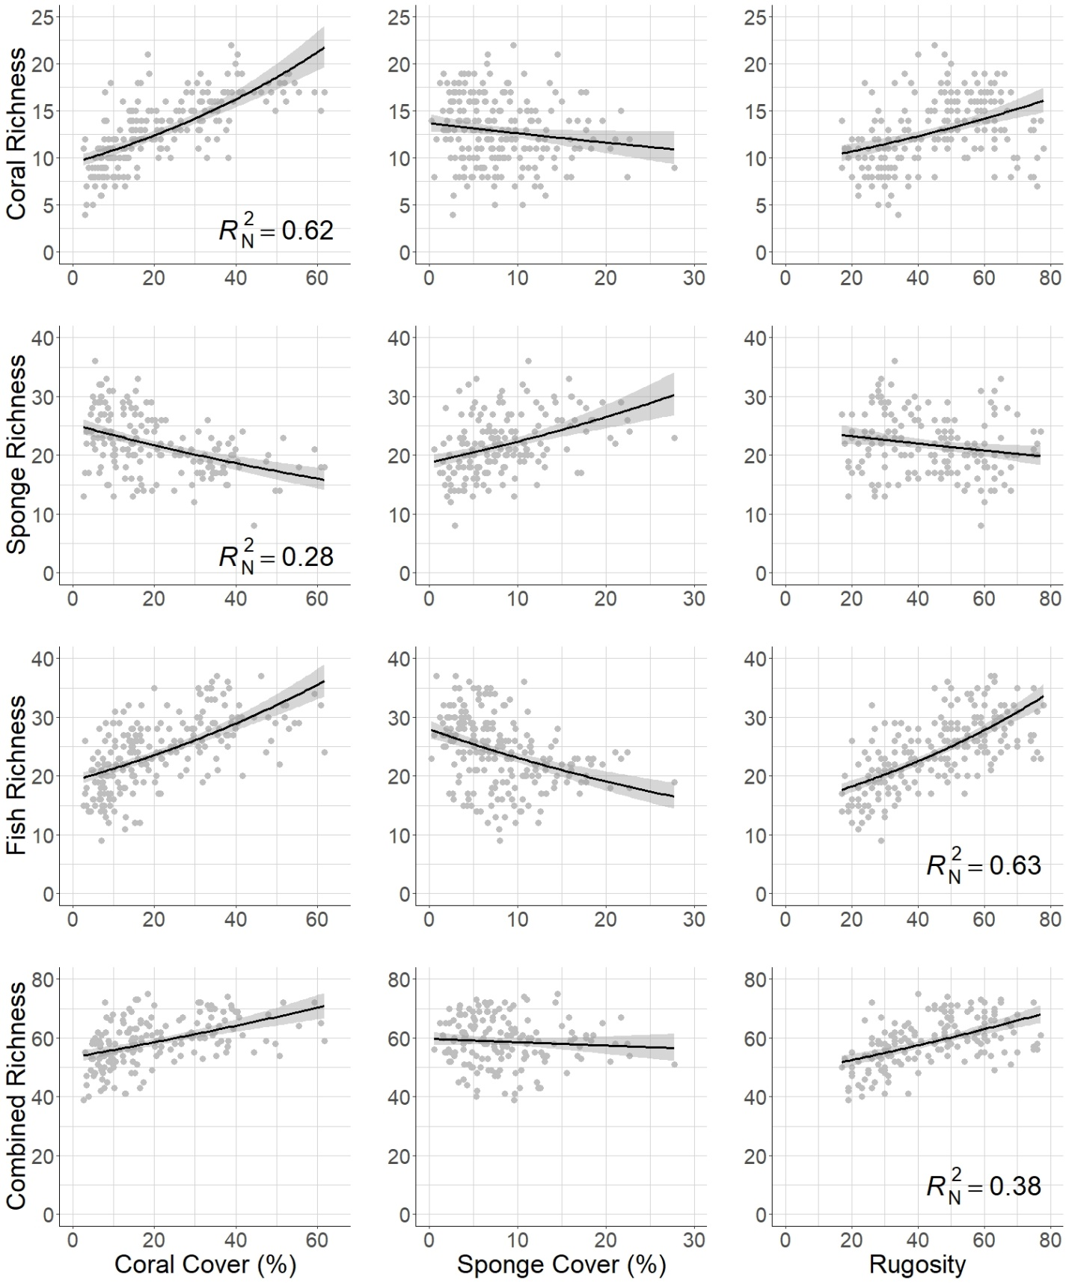Figure 2. Plots of the targets (rows) and candidate surrogates (columns). 95% confidence intervals shown. Nagelkerke’s pseudo-r-squared values (*R*N2) are shown for the top candidate surrogate for each of the targets.

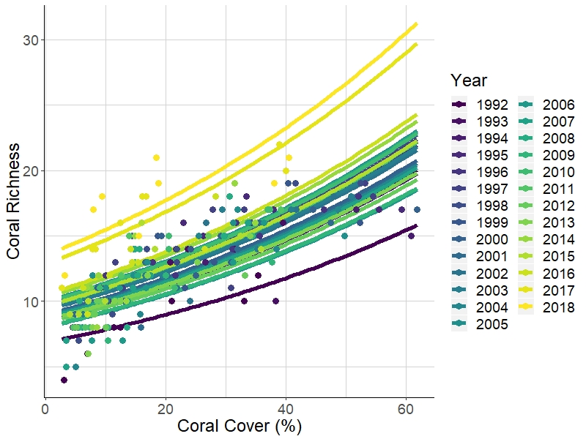

Figure 3. Temporal variation of coral richness as it varies with percent coral cover.

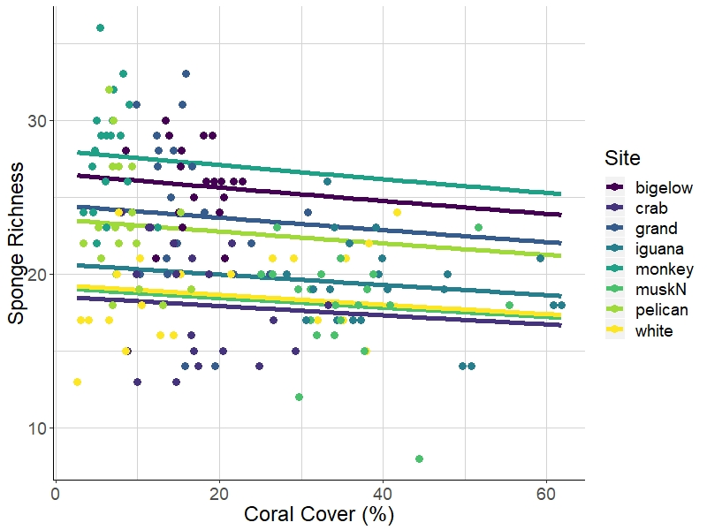

Figure 4. Spatial variation of coral richness as it varies with percent coral cover across 8 monitoring sites.

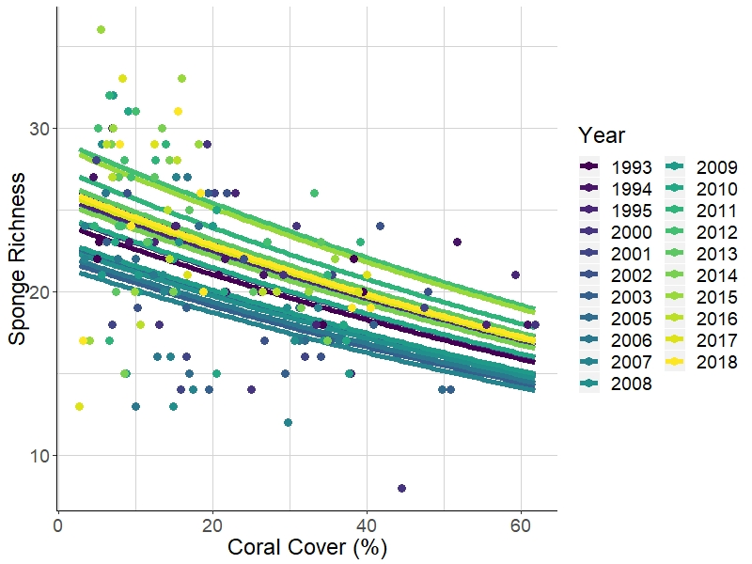

Figure 5. Temporal variation of sponge richness as it varies with percent coral cover.

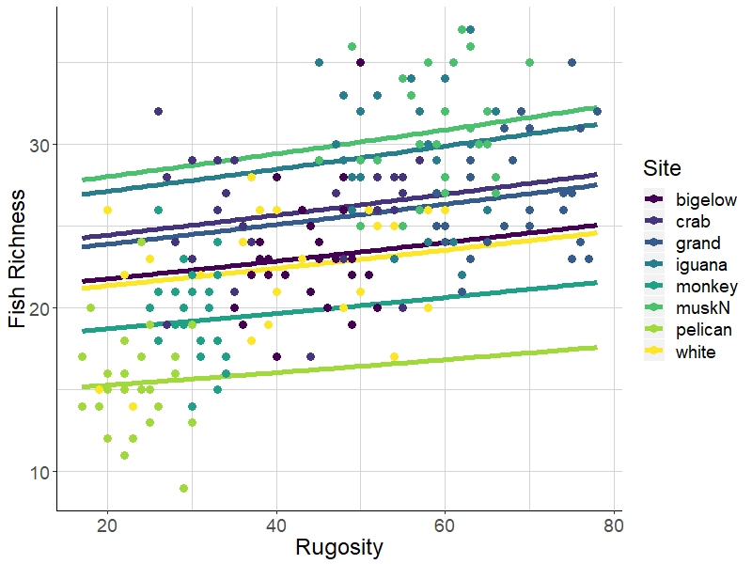

Figure 6. Spatial variation of fish richness as it varies with rugosity across 8 monitoring sites.

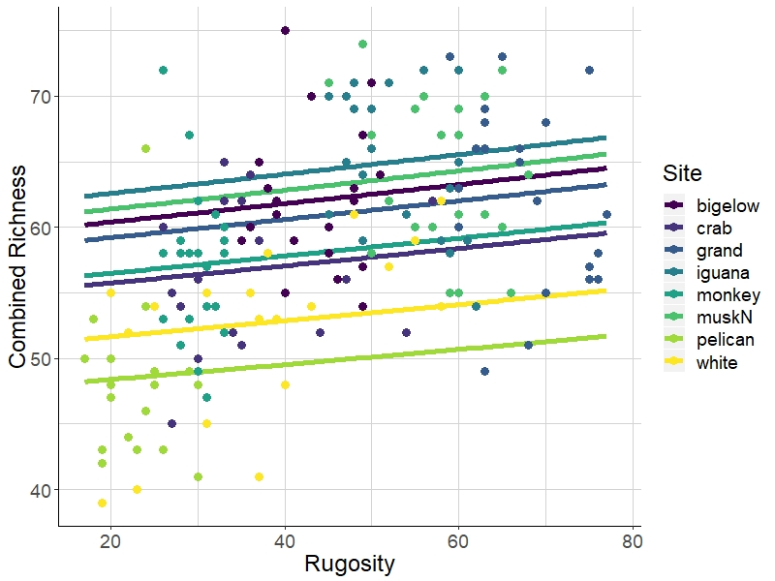

Figure 7. Spatial variation of combined richness as it varies with rugosity across 8 monitoring sites, where combined richness is the sum of richnesses of corals, fishes, and sponges.

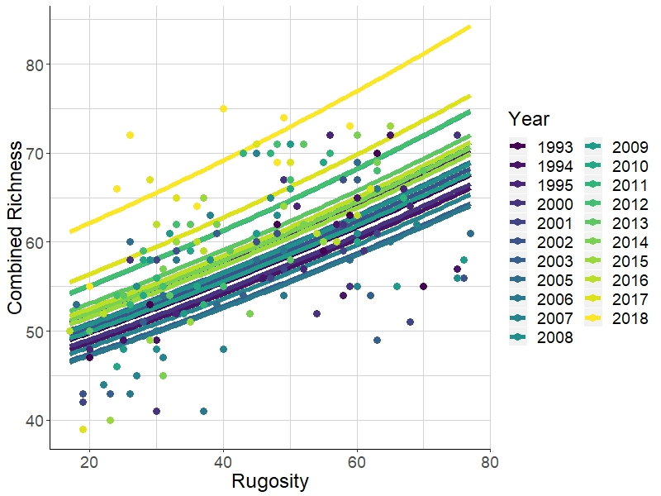

Figure 8. Temporal variation of combined richness as it varies with percent coral cover, where combined richness is the sum of richnesses of corals, fishes, and sponges.

Appendix 1. Fish species included in richness calculations.

|  |  |  |  |
| --- | --- | --- | --- |
| Fish species | Fish common name | Fish species cont. | Fish common name cont. |
| Abudefduf saxatilis | Sergeant major | Hypoplectrus chlorurus | yellowtail hamlet |
| Acanthurus bahianus | ocean surgeon | Hypoplectrus guttavarius | shy hamlet |
| Acanthurus chirurgus | doctorfish | Hypoplectrus indigo | indigo hamlet |
| Acanthurus coeruleus | blue tang | Hypoplectrus nigricans | black hamlet |
| Aluterus scriptus | scrawled filefish | Hypoplectrus puella | barred hamlet |
| Amblycirrhitus pinos | redspotted hawkfish | Hypoplectrus sp. | tan hamlet |
| Anisotremus surinamensis | black margate | Hypoplectrus unicolor | butter hamlet |
| Anisotremus virginicus | porkfish | Inermia vittata | boga |
| Aulostomus maculatus | trumpetfish | Kyphosus sectatrix | gray chub |
| Balistes capriscus | gray triggerfish | Lachnolaimus maximus | hogfish |
| Balistes vetula | queen triggerfish | Lactophrys bicaudalis | spotted trunkfish |
| Bodianus rufus | Spanish hogfish | Lactophrys quadricornis | scrawled cowfish |
| Calamus calamus | saucereye porgy | Lactophrys triqueter | smooth trunkfish |
| Calamus pennatula | pluma porgy | Lutjanus apodus | schoolmaster snapper |
| Cantherhines macrocerus | whitespotted filefish | Lutjanus griseus | gray snapper |
| Cantherhines pullus | orangespotted filefish | Lutjanus jocu | dog snapper |
| Canthigaster rostrata | sharp-nose puffer fish | Lutjanus mahogoni | mahogany snapper |
| Centropyge argi | cherubfish | Lutjanus synagris | lane snapper |
| Chaetodipterus faber | Atlantic spadefish | Melichthys niger | black durgon |
| Chaetodon ocellatus | spotfin butterflyfish | Microspathodon chrysurus | yellowtail damselfish |
| Chaetodon sedentarius | reef butterflyfish | Monacanthus ciliatus | fringed filefish |
| Chaetodon striatus | banded butterflyfish | Monacanthus tuckeri | slender filefish |
| Chaetodon capistratus | foureye butterflyfish | Mulloidichthys martinicus | yellow goatfish |
| Chromis cyanea | blue chromis | Mycteroperca tigris | tiger grouper |
| Chromis insolata | sunshinefish | Mycteroperca venenosa | yellowfin grouper |
| Chromis multilineata | brown chromis | Nicholsina usta | emerald parrotfish |
| Clepticus parrae | creole wrasse | Ocyurus chrysurus | yellowtail snapper |
| Cryptotomus roseus | bluelip parrotfish | Odontoscion dentex | reef croaker |
| Diodon hystrix | porcupinefish | Pomacanthus arcuatus | gray angelfish |
| Epinephelus adscensionis | rock hind | Pomacanthus paru | French angelfish |
| Epinephelus guttatus | red hind | Pomacentrus diencaeus | longfin damselfish |
| Epinephelus cruentatus | graysby | Pomacentrus leucostictus | beaugregory |
| Epinephelus fulva | coney | Pomacentrus variabilis | cocoa damselfish |
| Epinephelus striatus | Nassau grouper | Pomacentrus fuscus | dusky damselfish |
| Equetus acuminatus | high-hat | Pomacentrus partitus | bicolor damselfish |
| Equetus lanceolatus | jacknife fish | Pomacentrus planifrons | threespot damselfish |
| Equetus punctatus | spotted drum | Pseudupeneus maculatus | spotted goatfish |
| Gerres cinereus | yellowfin mojarra | Pterois volitans | lionfish |
| Gramma loreto | fairy basslet | Scarus coeruleus | blue parrotfish |
| Haemulon aurolineatum | tomtate grunt | Scarus croicensis | striped parrotfish |
| Haemulon carbonarium | Caesar grunt | Scarus guacamaia | rainbow parrotfish |
| Haemulon chrysargyreum | smallmouth grunt | Scarus taeniopterus | princess parrotfish |
| Haemulon flavolineatum | French grunt | Scarus vetula | queen parrotfish |
| Haemulon macrostomum | Spanish grunt | Serranus baldwini | lantern bass |
| Haemulon melanurum | cottonwick grunt | Serranus tabacarius | tobacco fish |
| Haemulon plumierii | white grunt | Serranus tigrinus | harlequin bass |
| Haemulon sciurus | blue striped grunt | Serranus tortugarum | chalk bass |
| Haemulon sp. unidentified | unidentified grunt | Sparisoma atomarium | greenblotch parrotfish |
| Haemulon striatum | striped grunt | Sparisoma aurofrenatum | redband parrotfish |
| Halichoeres bivittatus | slippery dick | Sparisoma chrysopterum | redtail parrotfish |
| Halichoeres cyanocephalus | yellowcheek wrasse | Sparisoma radians | bucktooth parrotfish |
| Halichoeres garnoti | yellowhead wrasse | Sparisoma rubripinne | yellowtail parrotfish |
| Halichoeres maculipinna | clown wrasse | Sparisoma viride | stoplight parrotfish |
| Halichoeres pictus | rainbow wrasse | Sphoeroides dorsalis | marbled puffer |
| Halichoeres poeyi | blackear wrasse | Sphoeroides spengleri | bandtail puffer |
| Halichoeres radiatus | puddingwife | Synodus intermedius | sand diver |
| Holacanthus ciliaris | queen angelfish | Synodus saurus | bluestripe lizardfish |
| Holacanthus tricolor | rock beauty | Synodus synodus | red lizardfish |
|  |  | Thalassoma bifasciatum | bluehead wrasse |

Appendix 2. Benthic species included in richness calculations.

|  |  |
| --- | --- |
| Coral species | Sponge species |
| Acropora cervicornis | Agelas citrina, Agelas clathrodes, or Clathria faviformis |
| Acropora palmata | Agelas conifera |
| Agaricia agaricites | Agelas spp. |
| Agaricia spp. (mostly Agaricia humilis and Agaricia lamarcki) | Aiolochroia crassa and Verongula rigida |
| Cladocora arbuscula | Amphimedon compressa |
| Colpophyllia natans | Amphimedon sp. (maybe Amphimedon complanata) |
| Dendrogyra cylindrus | Amphimedon viridis |
| Diploria labyrinthiformis | Aplysina fistularis, Aplysina fulva, and Aplysina insularis |
| Diploria strigosa and Diploria clivosa | Aplysina cauliformis |
| Dichocoenia stokesi | Aplysina lacunosa, Suberea sp., and Verongula reiswigi |
| Eusmilia fastigiata | Artemisina melana or Iotrochota arenosa |
| Favia fragum | Black, spiny, purple exudate, but not slimy |
| Helioceris cucullata | Breadcrumb (Calyx podatypa, Svenzea cristinae, or Svenzea zeai) |
| Isophyllia sinuosa | Callyspongia fallax |
| Manicina areolata | Like Callyspongia fallax but soft with pinched tube ends |
| Montastraea cavernosa | Callyspongia plicifera |
| Madracis mirabilis and Madracis decactis | Callyspongia vaginalis |
| Meandrina meandrites | Cervicornia cuspidifera |
| Montastraea annularis, M. franksi, M. faveolata (genus name now Orbicella) | Chondrilla caribensis |
| Mussa angulosa | Cinachyrella kuekenthali |
| Mycetophyllia ferox, Mycetophyllia lamarckiana | Clathria venosa |
| Oculina spp. | Clathria virgultosa |
| Porites astreoides | Cliona delitrix |
| Porites colonensis | Cliona laticavicola |
| Porites furcata | Cliona varians |
| Porites porites | Cribochalina vasculum and Petrosia pellasarca |
| Scolymia spp. | Desmapsamma anchorata |
| Siderastrea siderea and Siderastrea radians | Dictyonella funicularis |
| Solenastrea bournoni | Dragmacidon reticulatum |
| Stephanocoenia intersepta | Dysidea janiae |
|  | Dysidea sp. (maybe etheria) |
|  | Ectyoplasia ferox |
|  | Halisarca caerulea |
|  | Higginsia coralloides (may include Ptilocaulis walpersii) |
|  | Hyrtios sp. or Spheciospongia vesparium |
|  | Iotrochota birotulata |
|  | Iotrochota sp. |
|  | Ircinia campana |
|  | Ircinia felix |
|  | Ircinia strobilina |
|  | Maybe "Ircinia smooth" or Spongia |
|  | Monanchora arbuscula |
|  | Mycale laevis |
|  | Mycale laxissima |
|  | Neofibularia nolitangere |
|  | Neopetrosia proxima (may include Xestospongia subtriangularis) |
|  | Niphates erecta (may include Niphates amorpha) |
|  | Niphates sp. or Lissodendoryx sp.? |
|  | Orange encrusting |
|  | Pandaros acanthifolium |
|  | Plakortis sp. |
|  | Red Encrusting |
|  | Scopalina ruetzleri |
|  | Spirastrella coccinea and Spirastrella hartmani |
|  | Spongosorites coralliphaga |
|  | Tectitethya crypta |
|  | Unidentified |
|  | Xestospongia muta |

Appendix 3. AICc table of models with coral richness as the response variable (target). *K is the number of parameters in the model.

|  |  |  |  |  |  |
| --- | --- | --- | --- | --- | --- |
| **Model Name** | **K\*** | **AICc** | **Delta AICc** | **Akaike weight** | **Log-likelihood** |
| coralcover + year | 4 | 1044.2 | 0.0 | 0.58 | -518.0 |
| coralcover + year + year*coralcover | 5 | 1045.6 | 1.4 | 0.29 | -517.7 |
| coralcover + year + site | 11 | 1047.2 | 2.9 | 0.13 | -511.9 |
| coralcover | 3 | 1058.2 | 14.0 | 0.00 | -526.1 |
| coralcover + site | 10 | 1062.5 | 18.3 | 0.00 | -520.7 |
| coralcover + site + site*coralcover | 17 | 1064.2 | 19.9 | 0.00 | -513.5 |
| spongecover + site | 10 | 1078.7 | 34.5 | 0.00 | -528.8 |
| spongecover + year + site | 11 | 1080.9 | 36.7 | 0.00 | -528.8 |
| site | 9 | 1083.7 | 39.5 | 0.00 | -532.4 |
| rugosity + year + site | 11 | 1084.2 | 40.0 | 0.00 | -530.5 |
| rugosity + site | 10 | 1084.9 | 40.7 | 0.00 | -531.9 |
| year + site | 10 | 1085.4 | 41.2 | 0.00 | -532.2 |
| rugosity + site + site*rugosity | 17 | 1090.9 | 46.7 | 0.00 | -526.9 |
| year + site + year*site | 17 | 1091.3 | 47.1 | 0.00 | -527.1 |
| spongecover + site + site*spongecover | 17 | 1092.5 | 48.3 | 0.00 | -527.7 |
| rugosity + year | 4 | 1127.1 | 82.9 | 0.00 | -559.4 |
| rugosity + year + year*rugosity | 5 | 1128.0 | 83.7 | 0.00 | -558.8 |
| rugosity | 3 | 1131.2 | 87.0 | 0.00 | -562.5 |
| spongecover | 3 | 1161.1 | 116.9 | 0.00 | -577.5 |
| spongecover + year | 4 | 1162.2 | 118.0 | 0.00 | -577.0 |
| spongecover + year + year*spongecover | 5 | 1163.6 | 119.4 | 0.00 | -576.7 |
| year | 3 | 1165.0 | 120.8 | 0.00 | -579.5 |

Appendix 4. AICc table of models with sponge richness as the response variable (target). *K is the number of parameters in the model.

|  |  |  |  |  |  |
| --- | --- | --- | --- | --- | --- |
| **Model Name** | **K\*** | **AICc** | **Delta AICc** | **Akaike weight** | **Log-likelihood** |
| rugosity + year + site | 11 | 908.1 | 0.0 | 0.42 | -442.2 |
| year + site | 10 | 909.1 | 1.0 | 0.26 | -443.8 |
| coralcover + year + site | 11 | 909.3 | 1.2 | 0.23 | -442.8 |
| spongecover + year + site | 11 | 911.3 | 3.1 | 0.09 | -443.8 |
| year + site + year*site | 17 | 915.5 | 7.3 | 0.01 | -438.6 |
| site | 9 | 920.5 | 12.4 | 0.00 | -450.7 |
| coralcover + site | 10 | 922.3 | 14.1 | 0.00 | -450.4 |
| rugosity + site | 10 | 922.5 | 14.4 | 0.00 | -450.5 |
| spongecover + site | 10 | 922.5 | 14.4 | 0.00 | -450.5 |
| spongecover + site + site*spongecover | 17 | 929.4 | 21.2 | 0.00 | -445.6 |
| rugosity + site + site*rugosity | 17 | 931.2 | 23.0 | 0.00 | -446.5 |
| coralcover + site + site*coralcover | 17 | 933.8 | 25.7 | 0.00 | -447.8 |
| spongecover + year | 4 | 964.6 | 56.4 | 0.00 | -478.2 |
| coralcover + year | 4 | 966.3 | 58.1 | 0.00 | -479.0 |
| spongecover + year + year*spongecover | 5 | 966.3 | 58.2 | 0.00 | -478.0 |
| coralcover + year + year*coralcover | 5 | 966.6 | 58.5 | 0.00 | -478.1 |
| coralcover | 3 | 967.5 | 59.4 | 0.00 | -480.7 |
| spongecover | 3 | 973.9 | 65.8 | 0.00 | -483.9 |
| rugosity + year | 4 | 990.0 | 81.8 | 0.00 | -490.9 |
| rugosity + year + year*rugosity | 5 | 990.0 | 81.9 | 0.00 | -489.8 |
| year | 3 | 990.8 | 82.7 | 0.00 | -492.3 |
| rugosity | 3 | 995.4 | 87.2 | 0.00 | -494.6 |

Appendix 5. AICc table of models with fish richness as the response variable (target). *K is the number of parameters in the model.

|  |  |  |  |  |  |
| --- | --- | --- | --- | --- | --- |
| **Model Name** | **K\*** | **AICc** | **Delta AICc** | **Akaike weight** | **Log-likelihood** |
| site | 9 | 1203.3 | 0.0 | 0.27 | -592.2 |
| rugosity + site | 10 | 1203.8 | 0.5 | 0.21 | -591.4 |
| year + site | 10 | 1204.7 | 1.3 | 0.14 | -591.8 |
| coralcover + site | 10 | 1205.2 | 1.8 | 0.11 | -592.0 |
| spongecover + site | 10 | 1205.2 | 1.9 | 0.11 | -592.1 |
| rugosity + year + site | 11 | 1206.0 | 2.7 | 0.07 | -591.4 |
| spongecover + year + site | 11 | 1206.7 | 3.4 | 0.05 | -591.7 |
| coralcover + year + site | 11 | 1206.9 | 3.6 | 0.05 | -591.8 |
| year + site + year*site | 17 | 1216.5 | 13.2 | 0.00 | -589.7 |
| rugosity + site + site*rugosity | 17 | 1217.0 | 13.7 | 0.00 | -590.0 |
| spongecover + site + site*spongecover | 17 | 1218.7 | 15.3 | 0.00 | -590.8 |
| coralcover + site + site*coralcover | 17 | 1219.2 | 15.8 | 0.00 | -591.0 |
| rugosity + year + year*rugosity | 5 | 1260.9 | 57.6 | 0.00 | -625.3 |
| rugosity + year | 4 | 1261.6 | 58.3 | 0.00 | -626.7 |
| rugosity | 3 | 1266.3 | 62.9 | 0.00 | -630.1 |
| coralcover + year | 4 | 1292.0 | 88.7 | 0.00 | -641.9 |
| coralcover + year + year*coralcover | 5 | 1293.5 | 90.2 | 0.00 | -641.6 |
| coralcover | 3 | 1295.4 | 92.1 | 0.00 | -644.7 |
| spongecover | 3 | 1359.7 | 156.4 | 0.00 | -676.8 |
| spongecover + year + year*spongecover | 5 | 1360.8 | 157.5 | 0.00 | -675.3 |
| spongecover + year | 4 | 1361.8 | 158.4 | 0.00 | -676.8 |
| year | 3 | 1391.3 | 188.0 | 0.00 | -692.6 |

Appendix 6. AICc table of models with combined richness as the response variable (target). *K is the number of parameters in the model.

|  |  |  |  |  |  |
| --- | --- | --- | --- | --- | --- |
| **Model Name** | **K\*** | **AICc** | **Delta AICc** | **Akaike weight** | **Log-likelihood** |
| coralcover + year + site | 11 | 1071.3 | 0.0 | 0.98 | -523.8 |
| rugosity + year + site | 11 | 1079.7 | 8.4 | 0.01 | -528.0 |
| coralcover + site | 10 | 1083.0 | 11.7 | 0.00 | -530.8 |
| year + site | 10 | 1083.1 | 11.8 | 0.00 | -530.8 |
| spongecover + year + site | 11 | 1084.5 | 13.2 | 0.00 | -530.4 |
| year + site + year*site | 17 | 1084.8 | 13.5 | 0.00 | -523.3 |
| site | 9 | 1084.8 | 13.5 | 0.00 | -532.8 |
| spongecover + site | 10 | 1086.0 | 14.7 | 0.00 | -532.3 |
| rugosity + site | 10 | 1086.5 | 15.2 | 0.00 | -532.5 |
| rugosity + year | 4 | 1092.8 | 21.5 | 0.00 | -542.3 |
| rugosity + site + site*rugosity | 17 | 1093.2 | 21.9 | 0.00 | -527.5 |
| coralcover + site + site*coralcover | 17 | 1093.3 | 22.0 | 0.00 | -527.5 |
| rugosity + year + year*rugosity | 5 | 1094.8 | 23.5 | 0.00 | -542.2 |
| spongecover + site + site*spongecover | 17 | 1096.2 | 24.9 | 0.00 | -529.0 |
| coralcover + year | 4 | 1101.1 | 29.8 | 0.00 | -546.4 |
| coralcover + year + year*coralcover | 5 | 1103.2 | 31.9 | 0.00 | -546.4 |
| rugosity | 3 | 1106.8 | 35.5 | 0.00 | -550.3 |
| coralcover | 3 | 1116.3 | 45.0 | 0.00 | -555.1 |
| year | 3 | 1150.4 | 79.1 | 0.00 | -572.1 |
| spongecover + year | 4 | 1151.5 | 80.2 | 0.00 | -571.6 |
| spongecover + year + year*spongecover | 5 | 1152.7 | 81.4 | 0.00 | -571.1 |
| spongecover | 3 | 1153.8 | 82.5 | 0.00 | -573.8 |

1. Department of Natural Resources Science, University of Rhode Island, Kingston, RI 02881, USA ; nicole-keefner@uri.edu
2. Department of Natural Resources Science, University of Rhode Island, Kingston, RI 02881, USA; gforrester@uri.edu